
International School
Capstone Project 1
CMU-SE 450 – C1SE.06
User Interface Design
Version 1.0
Date: Nov 5th, 2026
SFDS
Scam Fraud Detection System with Explanations
Created by
Hao, Pham Tan
Nhung, Dao Thi My
Nam, Tran Hoang Nhat
Tuan, Nguyen Phan Duc
Approved by
Eng. Toan, Ha Manh
User Interface Design Review Panel Representative:
Name: ________________________ Signature: ________________________ Date: ____________
Capstone Project 1 - Mentor:
Name: ________________________ Signature: ________________________ Date: ____________

PROJECT INFORMATION
Project acronym | SFDS
Project Title | “SFDS” – Scam Fraud Detection System with Explanations
Start Date | 02 Sep 2026 | End Date | 15 Dec 2026
Lead Institution | International School, Duy Tan University
Project Mentor | Eng. Ha Manh Toan (Email: lhttuy@gmail.com)
Product Owner / Leader | Hao, Pham Tan Email: phamtanhao1909@gmail.com Tel: 0961 651 933 ID: 29219020823
Scrum master / UI Lead | Nhung, Dao Thi My Email: mynhung150905@gmail.com Tel: 0376 415 338 ID: 29209200048
Partner Organization | Duy Tan University
Team members:
No. | Name | Email | Tel
1 | Hao, Pham Tan | phamtanhao1909@gmail.com | 0961651933
2 | Nhung, Dao Thi My | mynhung150905@gmail.com | 0376415338
3 | Nam, Tran Hoang Nhat | trannamnhathoang@gmail.com | 0795798736
4 | Tuan, Nguyen Phan Duc | ductuan02072005@gmail.com | 0932442770

DOCUMENT APPROVALS
The following signatures are required for approval of this document.
Stakeholder | Signature | Date
Eng. Ha Manh Toan  Project Mentor  Duy Tan University | Signature: _______________ | Date: 05/11/2026
Nhung, Dao Thi My  Student ID: 29209200048  QA Lead / UI-UX Lead | Signature: _______________ | Date: 05/11/2026
Hao, Pham Tan  Student ID: 29219020823  Project Leader / Scrum Master | Signature: _______________ | Date: 05/11/2026
Nam, Tran Hoang Nhat  Student ID: 29219423638  Frontend Developer | Signature: _______________ | Date: 05/11/2026
Tuan, Nguyen Phan Duc  Student ID: 29211151140  AI Lead | Signature: _______________ | Date: 05/11/2026

REVISION HISTORY
Version | Date | Comments | Author | Approval
1.0 | 05/11/2026 | Initial Release - Full UI/UX Design Specification | Nhung, Dao Thi My | Eng. Ha Manh Toan
2.0 | 05/11/2026 | Official Capstone User Interface Design Document (Synchronized with Codebase) | Nhung, Dao Thi My | Eng. Ha Manh Toan

TABLE OF CONTENTS
1. Introduction ............................................................ 4
1.1. Purpose ............................................................ 4
1.2. Scope .............................................................. 4
2. Interface Design ........................................................ 5
2.1 Overview (Portal Landing & Threat Intelligence) ..................... 5
2.2 Multimodal Scan Interface ........................................... 7
2.3 Explainable Risk Verdict & CoT Reasoning ............................ 9
2.4 Scan History & Forensic Audit ....................................... 12
2.5 User Profile & Personal Space ....................................... 14
2.6 Admin Security Gate (Admin Authentication) .......................... 16
2.7 Admin Control Center & Model Governance ............................. 18
3. Design System & Guidelines .............................................. 21
3.1 Typography & Color Hierarchy ........................................ 21
3.2 Accessibility & Responsive Adaptation ............................... 22

1. Introduction
1.1. Purpose
This specification covers the following aspects:
The documentation provides a detailed description of the user interface (UI) and user experience (UX) design for the “SFDS – Scam Fraud Detection System with Explanations” platform. It explains how the system supports Vietnamese citizens, enterprise security teams (SMEs), and administrative cyber analysts in identifying and mitigating sophisticated online scam campaigns through multimodal AI-driven video, image, text, and URL forensics.
With this documentation, the frontend engineering, QA, and security development teams can clearly understand the component hierarchy, visual layouts, interaction states, input validation rules, and accessibility standards required to build a consistent, responsive, and human-centric cyber safety application.
1.2. Scope
The SFDS user experience is purposely designed to be frictionless for public citizens while strictly controlled for system administrators:
• Frictionless Public Access (No Registration Required): Regular citizens can immediately access the portal, perform scans across multiple modalities (URL, screenshots, messages, document scans), and view explainable AI verdicts without being required to create or register an account. This design eliminates onboarding friction, encouraging immediate threat verification during urgent suspicious interactions.
• Client-Side Persistence: Historical scan logs and forensic audit trails for public users are persisted directly on the client device via browser localStorage (capped at 50 records), preserving privacy and eliminating unneeded database overhead.
• Privileged Admin Security Gate: A dedicated Admin Gate enforces secure JWT authentication for authorized personnel, granting access to training dataset curation, AI model lifecycle management, performance evaluations, and system audit logs.

2. Interface Design
2.1 Overview (Portal Landing & Threat Intelligence)
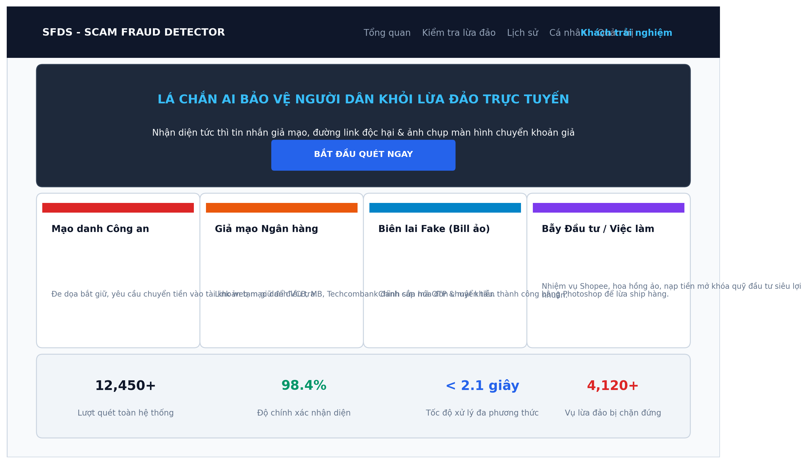
Figure 1. UI Overview / Portal Landing Page
Table 1. Description UI Overview
No. | Field name | Type | Require | Target
1 | navBrandLogo | Logo + Text | Position: Top left; Text: 'SFDS - SCAM FRAUD DETECTOR' | Brand logo navigating to homepage
2 | topNavbarLinks | Navigation | Links: 'Tổng quan', 'Kiểm tra lừa đảo', 'Lịch sử', 'Cá nhân', 'Quản trị' | Primary navigation bar across application modules
3 | userStatusPill | Status Badge | Position: Top right; Text: 'Khách trải nghiệm' / 'Admin' | Display current session state and privileges
4 | heroBannerTitle | Heading | Font: Bold 14pt; Text: 'LÁ CHẮN AI BẢO VỆ NGƯỜI DÂN...' | Headline communicating platform cyber safety mission
5 | quickScanCTA | Button | Solid Blue; Pill shape; Text: 'BẮT ĐẦU QUÉT NGAY' | One-click shortcut directing citizens into scan interface
6 | threatCard_Police | Card | Red tag; Title: 'Mạo danh Công an'; Explanatory summary | Warn citizens regarding fake arrest warrants & coercive threats
7 | threatCard_Bank | Card | Orange tag; Title: 'Giả mạo Ngân hàng'; Explanatory summary | Warn citizens against deceptive phishing URLs and OTP theft
8 | threatCard_Bill | Card | Sky-blue tag; Title: 'Biên lai Fake'; Explanatory summary | Educate users on fake bank transfer receipt tampering
9 | threatCard_Job | Card | Purple tag; Title: 'Bẫy Đầu tư / Việc làm'; Explanatory summary | Expose recruitment commission and ponzi scheme traps
10 | statTotalScans | KPI Metric | Value: '12,450+'; Subtext: 'Lượt quét toàn hệ thống' | Demonstrate public adoption and platform operational scale
11 | statAccuracy | KPI Metric | Value: '98.4%'; Green color; Subtext: 'Độ chính xác' | Build citizen confidence in AI multimodal consensus accuracy
12 | statLatency | KPI Metric | Value: '< 2.1 giây'; Blue color; Subtext: 'Tốc độ xử lý' | Demonstrate instant, sub-second inspection performance

2.2 Multimodal Scan Interface
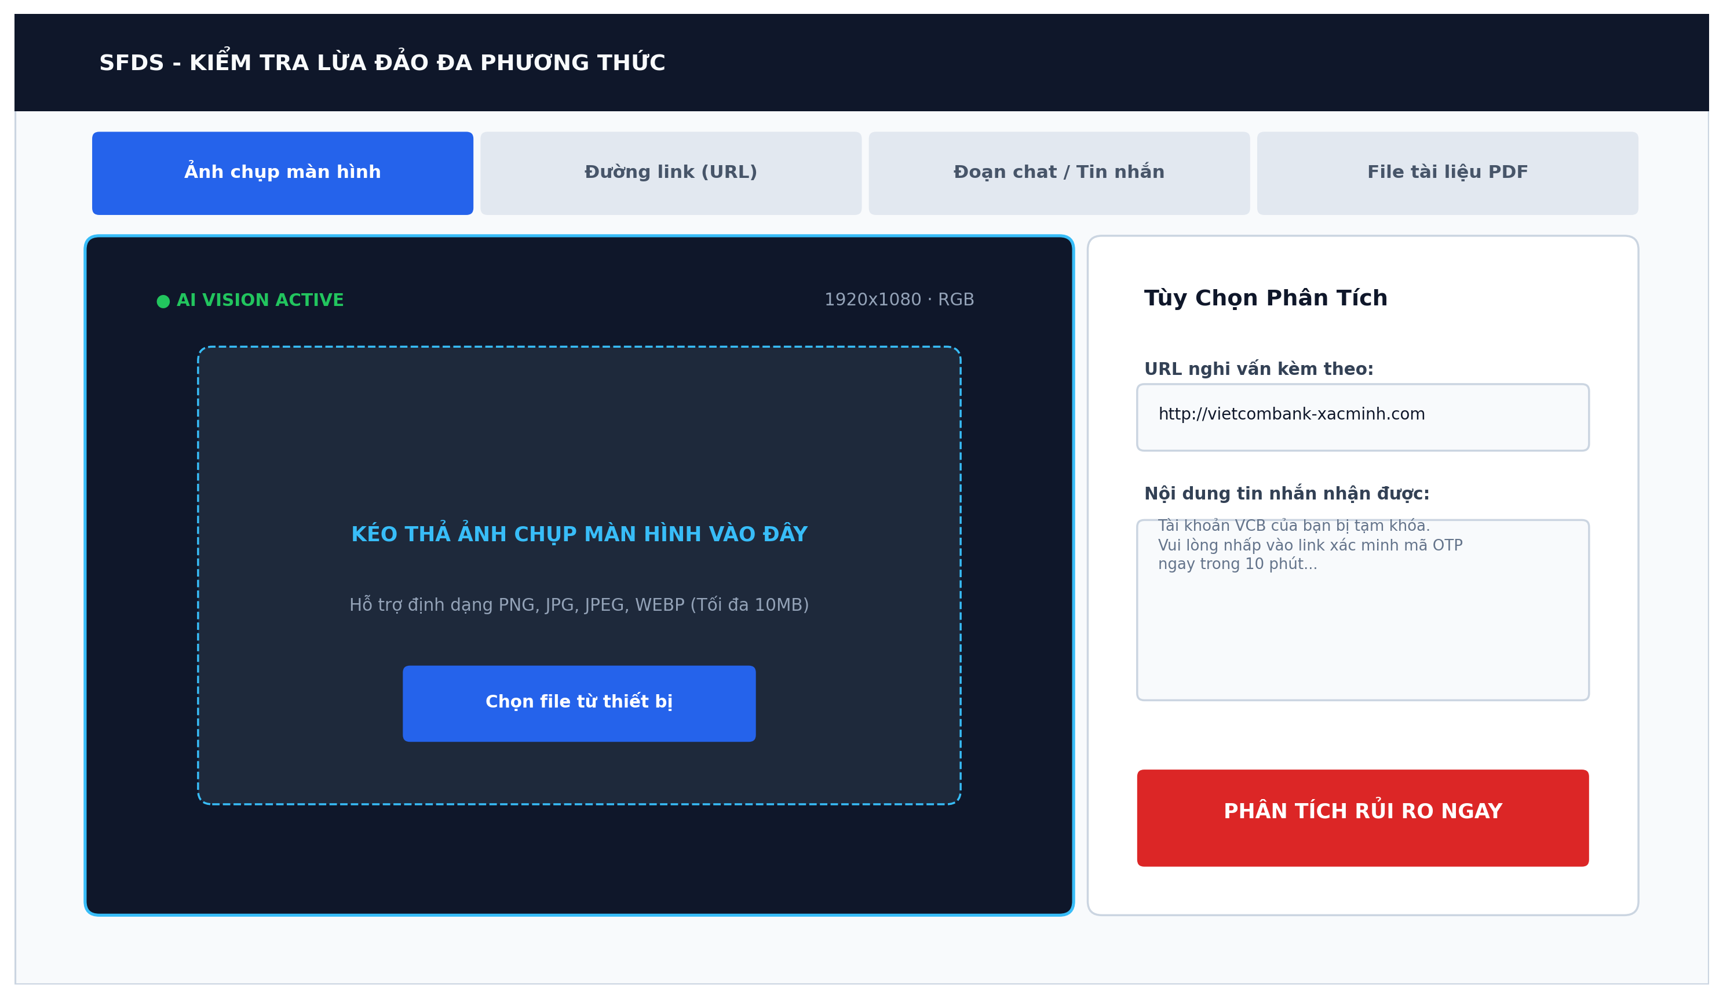
Figure 2. UI Multimodal Scan Viewport
Table 2. Description UI Multimodal Scan Interface
No. | Field name | Type | Require | Target
1 | tabImage | Tab Button | Active blue; Icon: Camera; Label: 'Ảnh chụp màn hình' | Select screenshot inspection mode (ResNet-18 + ELA forensics)
2 | tabURL | Tab Button | Inactive state; Icon: Link; Label: 'Đường link (URL)' | Select URL lexical inspection mode (PhishVN feature extractor)
3 | tabMessage | Tab Button | Inactive state; Icon: Chat; Label: 'Đoạn chat / Tin nhắn' | Select conversational text inspection mode (NLP Risk Lexicon)
4 | tabPDF | Tab Button | Inactive state; Icon: File; Label: 'File tài liệu PDF' | Select legal document scanning mode (Tesseract OCR Engine)
5 | viewportContainer | HUD Viewport | Dark tech aesthetic (#0F172A); Laser grid border | Visual canvas previewing evidence and bounding box annotations
6 | hudStatusBadge | Status Pill | Glowing green indicator; Text: 'AI VISION ACTIVE' | Inform citizen that AI visual pipeline is online and ready
7 | dragDropZone | Drop Target | Dashed cyan outline; Interactive drag-and-drop listener | Allow drag-and-drop or file picker upload (PNG, JPG up to 10MB)
8 | browseFileButton | Button | Solid Blue; Text: 'Chọn file từ thiết bị' | Trigger native OS file selection dialogue for uploading proof
9 | urlInputAux | Input Field | Placeholder: 'http://vietcombank-xacminh.com'; Clear icon | Allow entering matching URL accompanying the screenshot proof
10 | messageInputAux | Text Area | Multi-line text; Max 2000 chars; Scrollbar auto | Allow pasting message transcript received alongside the screenshot
11 | executeScanButton | Button | Solid Red (#DC2626); Pulsing glow; Text: 'PHÂN TÍCH RỦI RO NGAY' | Submit multimodal payload to FastAPI orchestrator for analysis

2.3 Explainable Risk Verdict & CoT Reasoning
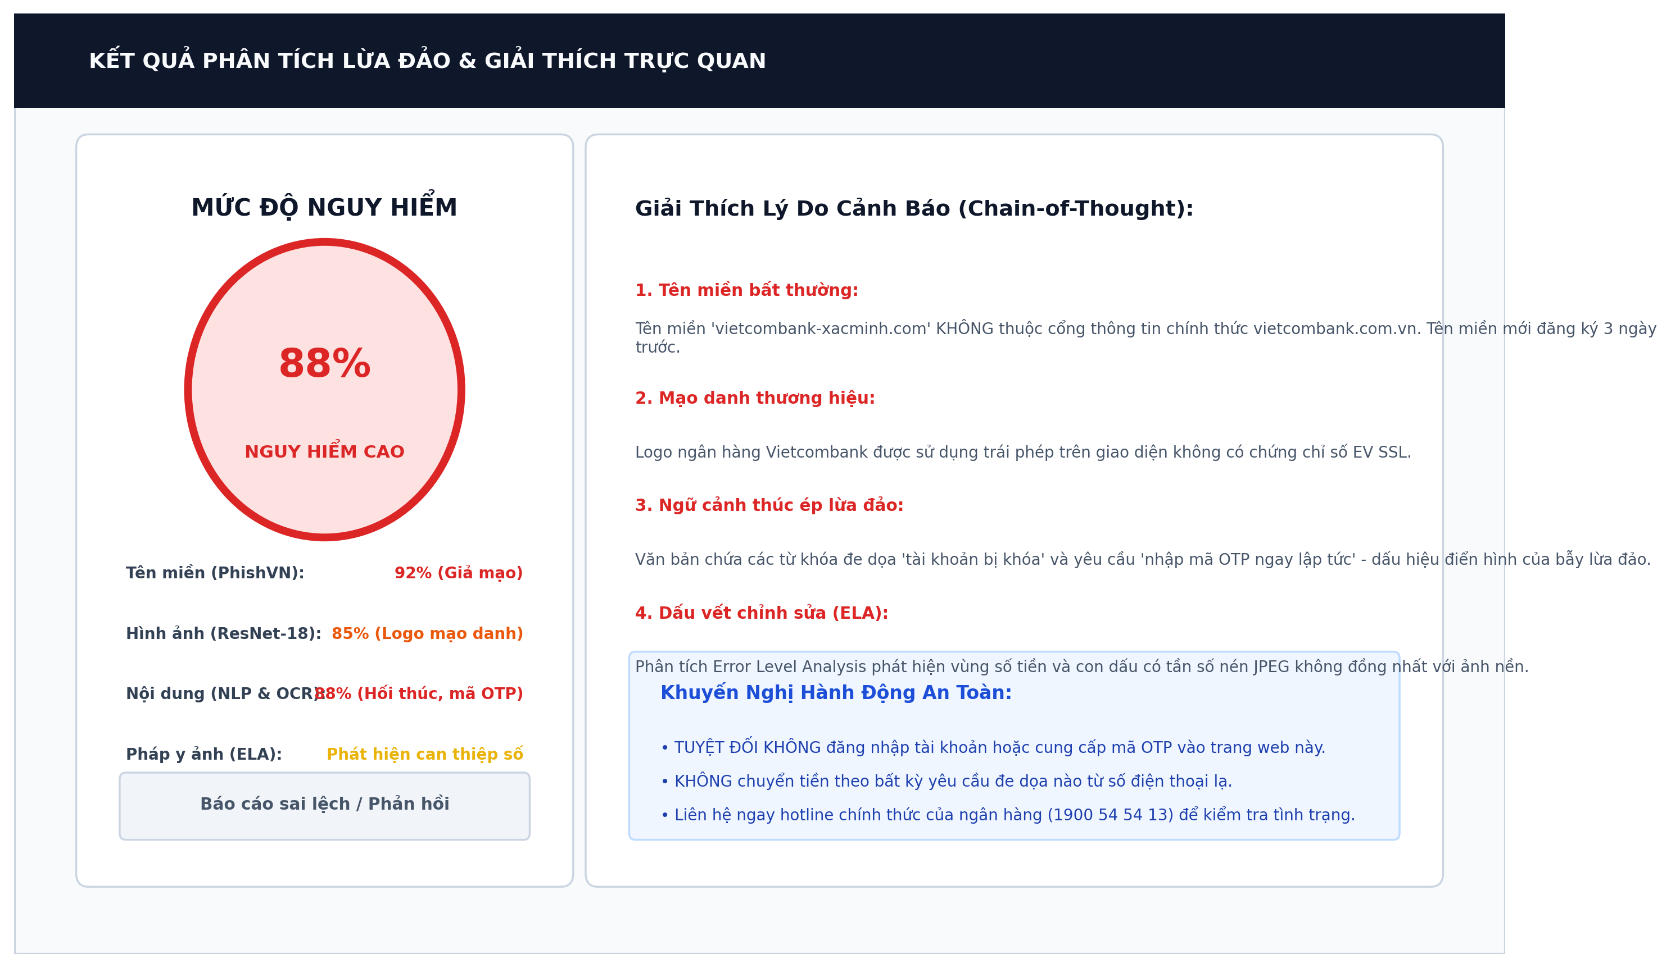
Figure 3. UI Risk Analysis & Verdict Explanation
Table 3. Description UI Risk Analysis & Verdict
No. | Field name | Type | Require | Target
1 | riskGaugeCard | Card Container | Left panel; High-contrast border; White background | Group comprehensive risk score and sub-modal metrics
2 | gaugeVisualCircle | Radial Gauge | Circular gauge 0-100; Value: '88%'; Red stroke (#DC2626) | Visually signal urgent threat severity to citizens instantaneously
3 | verdictBadge | Label Badge | Caps bold; Background: Light Red; Text: 'NGUY HIỂM CAO' | Categorical rating (An toàn <40%, Nghi ngờ 40-69%, Nguy hiểm >=70%)
4 | scorePhishVN | Metric Item | Text: 'Tên miền: 92% (Giả mạo)'; Red indicator | Display URL lexical fraud contribution from PhishVN model
5 | scoreResNet | Metric Item | Text: 'Hình ảnh: 85% (Logo mạo danh)'; Orange indicator | Display visual brand classification score from ResNet-18 CNN
6 | scoreNLP | Metric Item | Text: 'Nội dung: 88% (Hối thúc, mã OTP)'; Red indicator | Display linguistic threat score from Vietnamese scam lexicon
7 | scoreELA | Metric Item | Text: 'Pháp y ảnh: Phát hiện can thiệp số'; Yellow indicator | Display Error Level Analysis compression artifact flag
8 | feedbackModalButton | Button | Outline button; Flag icon; Text: 'Báo cáo sai lệch / Phản hồi' | Trigger community feedback modal to appeal false positive/negative
9 | cotExplanationList | List Group | Numbered steps (1 to 4); Red highlighted headings | Synthesize plain-language Chain-of-Thought (CoT) reasoning reasons
10 | cotStep1_Domain | List Item | Text: 'Tên miền bất thường: vietcombank-xacminh.com...' | Explain domain age and spoofing technique used
11 | cotStep2_Visual | List Item | Text: 'Mạo danh thương hiệu: Logo ngân hàng Vietcombank...' | Explain unauthorized brand logo usage and counterfeit UI layout
12 | cotStep3_Urgency | List Item | Text: 'Ngữ cảnh thúc ép: Yêu cầu mã OTP khẩn cấp...' | Explain psychological manipulation and urgency tactics detected
13 | cotStep4_Forensics | List Item | Text: 'Dấu vết chỉnh sửa (ELA): Số tiền bị làm mờ...' | Explain digital image tampering identified on the evidence
14 | actionGuidanceBox | Callout Box | Light blue background (#EFF6FF); Blue border; Lightbulb icon | Provide specific, actionable security instructions to prevent losses

2.4 Scan History & Forensic Audit
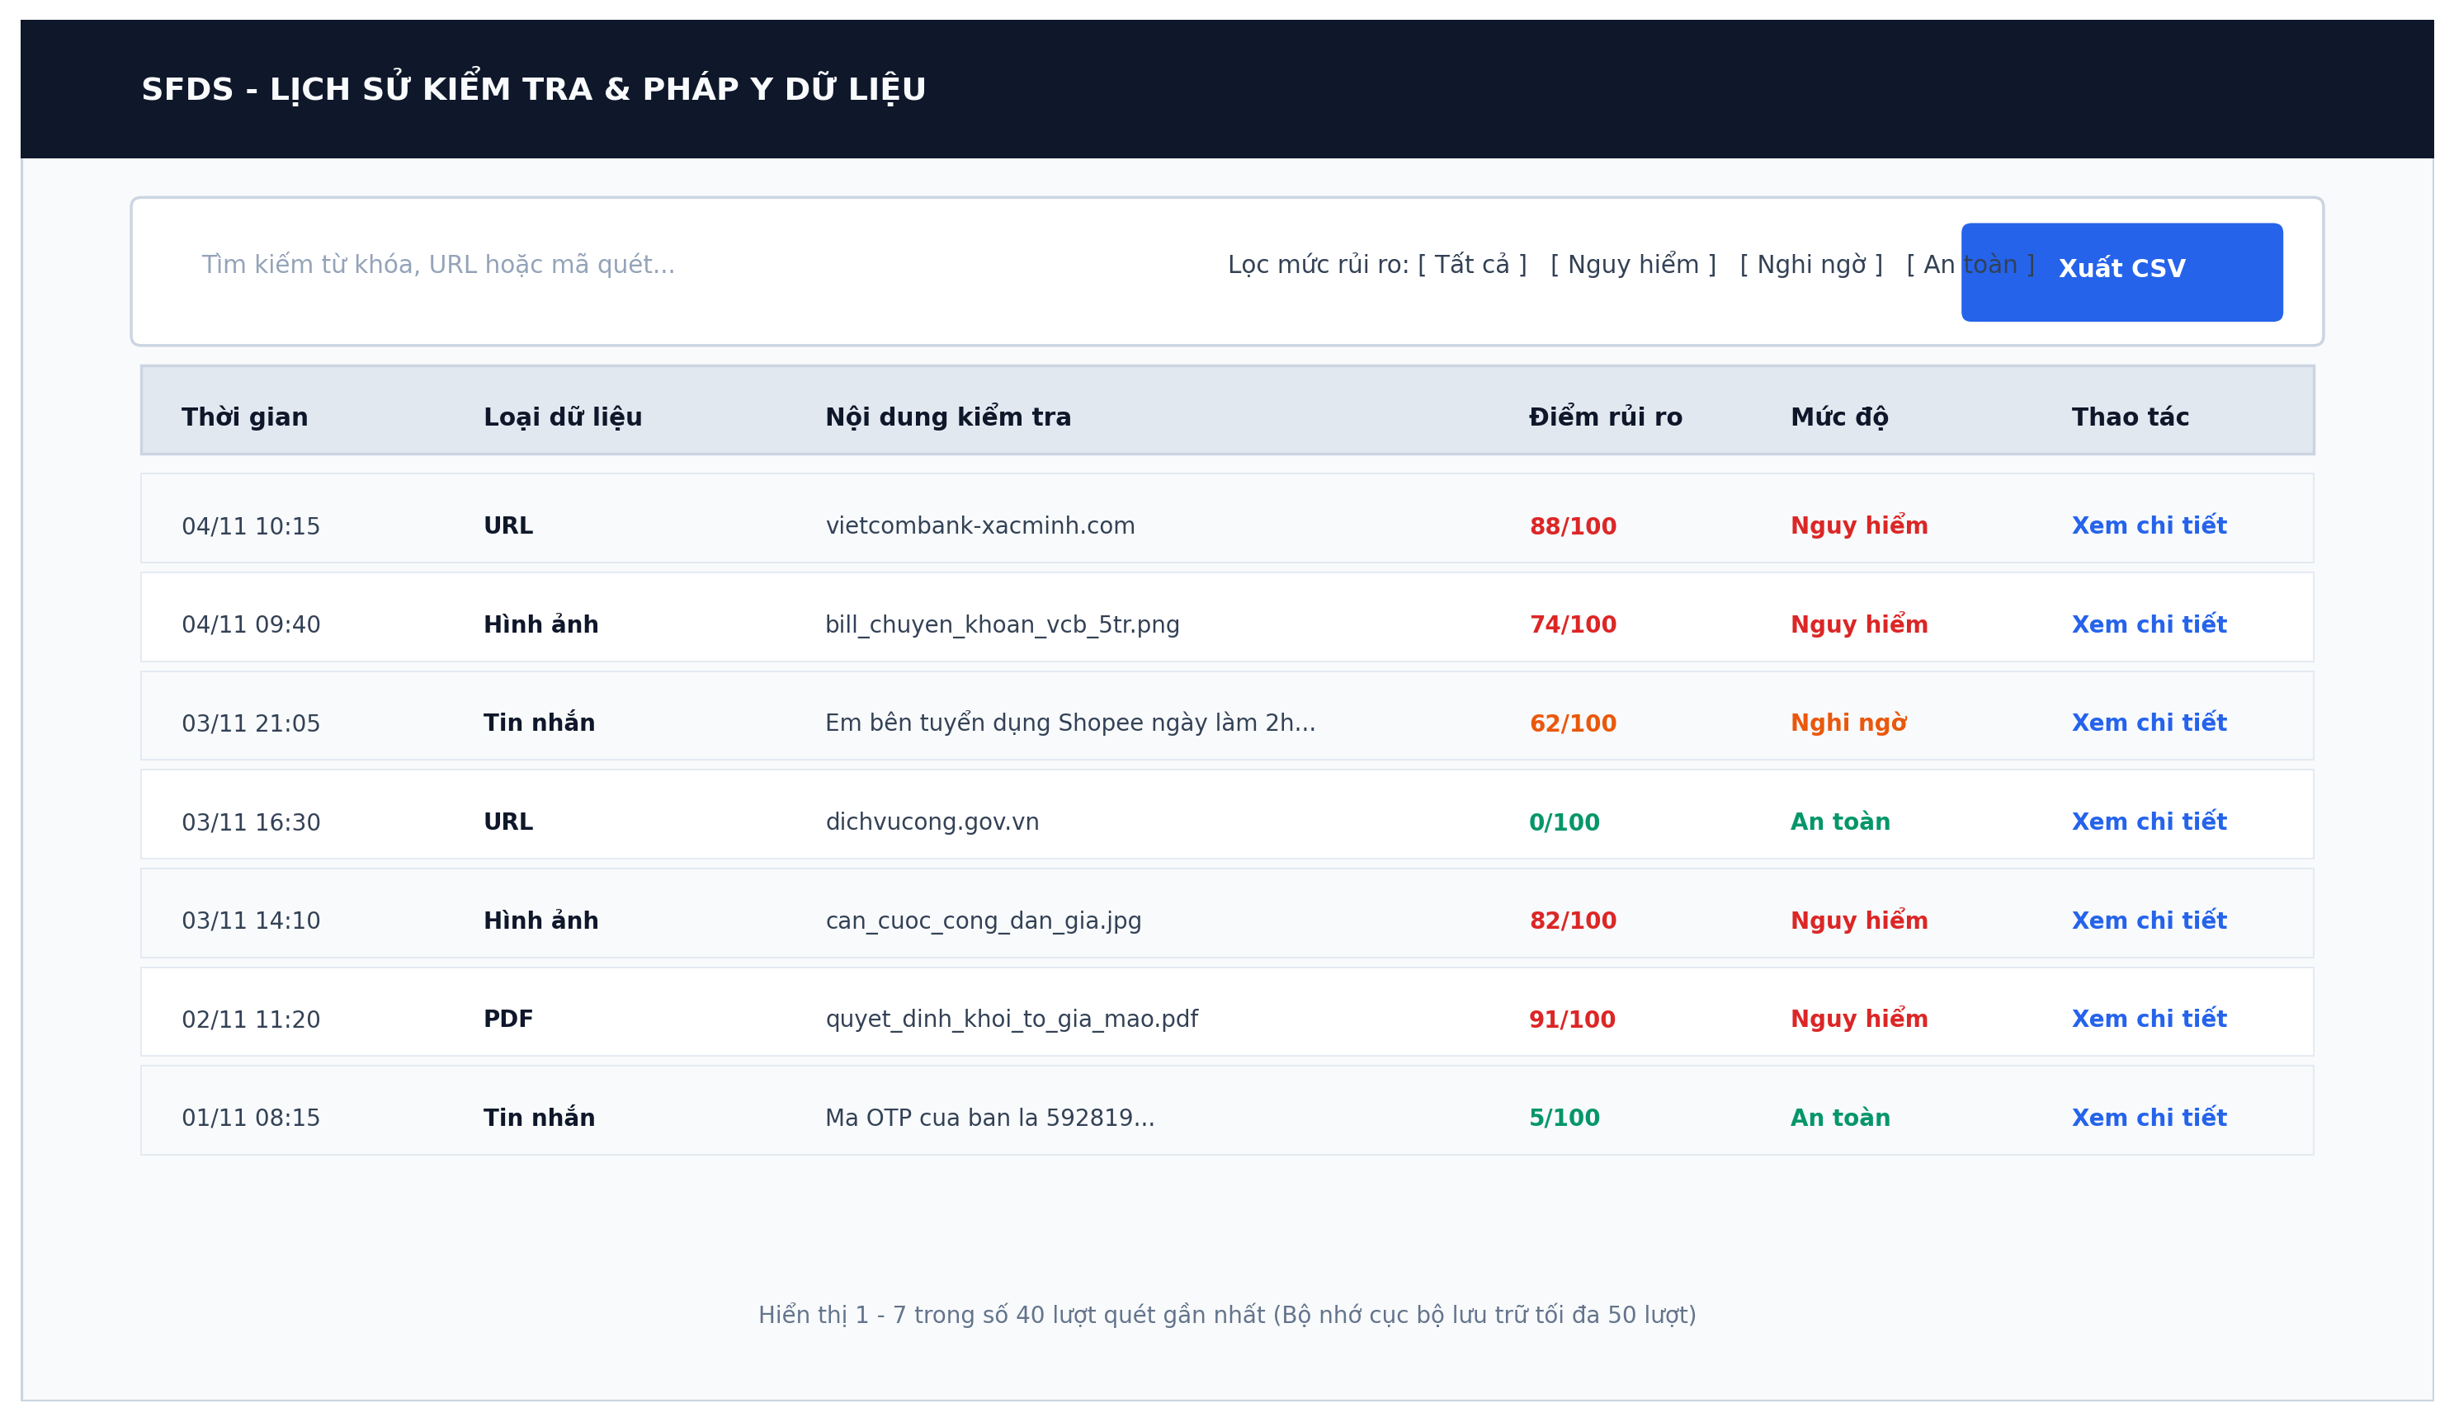
Figure 4. UI Scan History & Local Audit Trail
Table 4. Description UI Scan History
No. | Field name | Type | Require | Target
1 | searchFilterBar | Input Field | Placeholder: 'Tìm kiếm từ khóa, URL hoặc mã quét...' | Filter inspection history by input domain or message snippet
2 | riskFilterPills | Filter Group | Interactive chips: [Tất cả] [Nguy hiểm] [Nghi ngờ] [An toàn] | Filter history table by categorical risk classification
3 | exportCSVButton | Button | Solid Blue; Download icon; Text: 'Xuất CSV' | Export client-side scan audit logs into CSV spreadsheet
4 | tableHeader_Time | Table Header | Text: 'Thời gian'; Center alignment | Display scan execution timestamp (DD/MM HH:mm)
5 | tableHeader_Type | Table Header | Text: 'Loại dữ liệu'; Badges: URL, Hình ảnh, Tin nhắn, PDF | Display input modality used during inspection
6 | tableHeader_Content | Table Header | Text: 'Nội dung kiểm tra'; Truncated text preview | Display submitted target URL or file name
7 | tableHeader_Score | Table Header | Text: 'Điểm rủi ro'; Format: XX/100; Colored text | Display numerical multimodal risk score
8 | tableHeader_Level | Table Header | Text: 'Mức độ'; Badges: An toàn (Xanh), Nguy hiểm (Đỏ) | Display human-readable categorical severity
9 | actionReplayDetail | Action Button | Text: 'Xem chi tiết'; Hyperlink style | Re-open full CoT reasoning modal without re-running backend scan
10 | storageIndicator | Footer Text | Text: 'Bộ nhớ cục bộ lưu trữ tối đa 50 lượt gần nhất' | Inform user that data is persisted securely in browser localStorage

2.5 User Profile & Personal Space
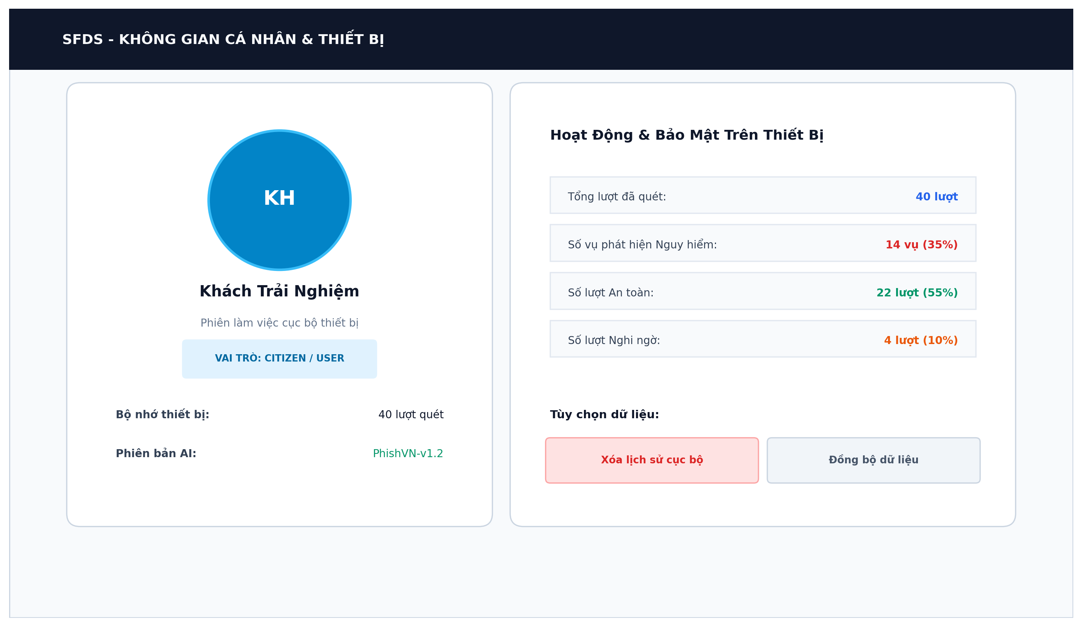
Figure 5. UI User Profile & Personal Device Space
Table 5. Description UI User Profile
No. | Field name | Type | Require | Target
1 | profileAvatar | Avatar Circle | Initials badge; Text: 'KH' / 'AD'; Cyan border | Visual avatar generated from display name or role
2 | profileDisplayName | Text Heading | Text: 'Khách Trải Nghiệm' (hoặc tên Admin); Editable | Display current session identity
3 | profileRoleBadge | Role Pill | Text: 'VAI TRÒ: CITIZEN / USER' (hoặc 'ADMIN') | Display role-based permissions and privilege tier
4 | deviceStorageCounter | Text Metric | Text: 'Bộ nhớ thiết bị: 40 lượt quét' | Display total local scan records stored in device localStorage
5 | aiVersionIndicator | Text Metric | Text: 'Phiên bản AI: PhishVN-v1.2' | Display current active model checkpoint deployed on system
6 | statsDangerousCount | Data Row | Text: 'Số vụ phát hiện Nguy hiểm: 14 vụ (35%)'; Red color | Quantify threats prevented on current user device
7 | statsSafeCount | Data Row | Text: 'Số lượt An toàn: 22 lượt (55%)'; Green color | Quantify benign scans confirmed on current user device
8 | clearHistoryButton | Button | Light Red background (#FEE2E2); Text: 'Xóa lịch sử cục bộ' | Wipe browser localStorage scan logs for privacy protection
9 | syncDataButton | Button | Light Gray background (#F1F5F9); Text: 'Đồng bộ dữ liệu' | Trigger synchronization with cloud persistence layer (if authenticated)

2.6 Admin Security Gate (Admin Authentication)
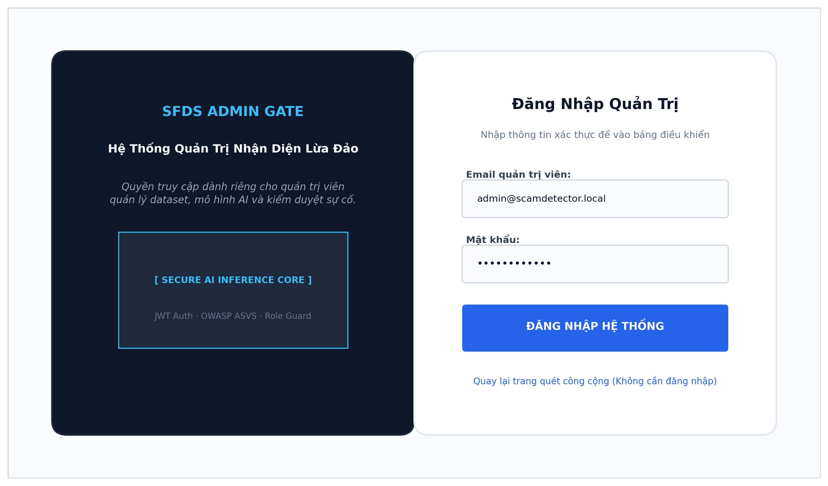
Figure 6. UI Admin Security Gate
Table 6. Description UI Admin Security Gate
No. | Field name | Type | Require | Target
1 | showcaseBrand | Logo + Text | Brand shield logo; Text: 'SFDS ADMIN GATE' | Display system brand identity and privileged gateway status
2 | showcaseTitle | Text Heading | Font-weight: Bold; Text: 'Khu vực quản trị hệ thống' | Welcome administrative personnel to secure zone
3 | showcaseDesc | Text Description | Text: 'Quyền truy cập dành riêng cho quản trị viên...' | Explain role-based access restrictions and responsibilities
4 | coreVisual | HUD Graphic | Glowing radar core; Nodes: DB, LOG, AI; Label: 'ADMIN GATE' | Reinforce cryptographic and AI security trust visually
5 | loginTitle | Text Heading | Font-weight: Bold; Text: 'Đăng Nhập Quản Trị' | Form title on the right login card
6 | emailInput | Input Field | Placeholder: 'admin@scamdetector.local'; Email format check | Allow administrator to enter username/email address
7 | passwordInput | Input Field | Type: Password; Includes visibility toggle; Required | Allow administrator to enter secure account password
8 | submitButton | Button | Full-width; Solid Blue (#2563EB); Text: 'ĐĂNG NHẬP HỆ THỐNG' | Submit credentials to FastAPI /auth/login for JWT issuance
9 | publicBackLink | Text Link | Text: 'Quay lại trang quét công cộng (Không cần đăng nhập)' | Navigate non-admin citizens back to instant public scan portal

2.7 Admin Control Center & Model Governance
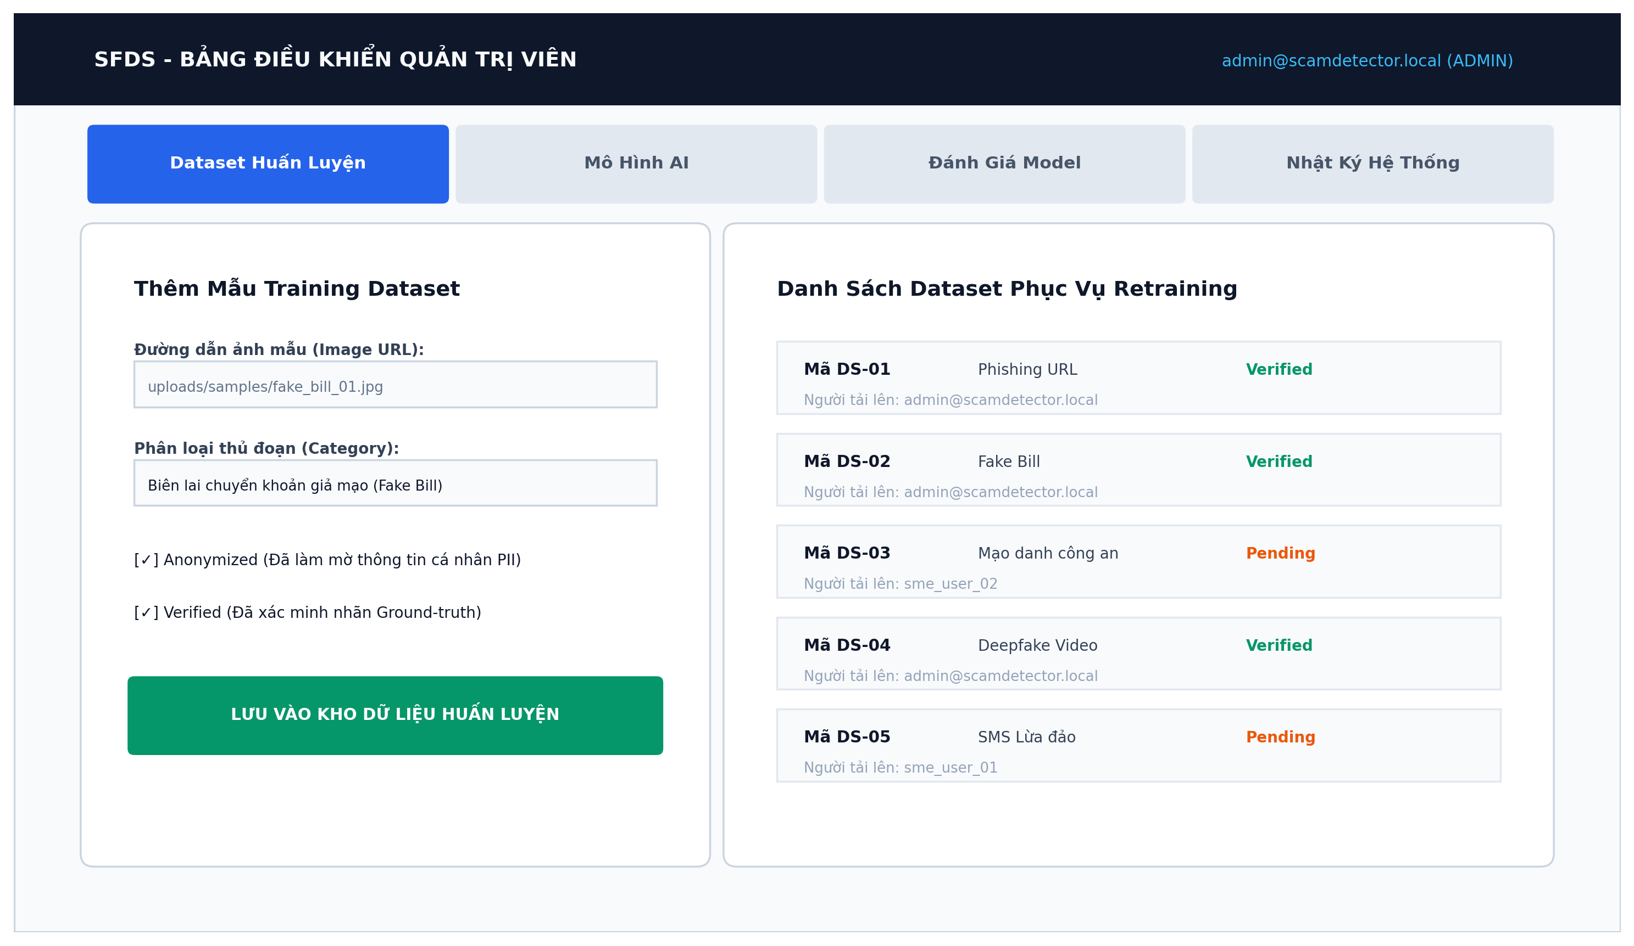
Figure 7. UI Admin Control Center (Dataset & Model Management)
Table 7. Description UI Admin Control Center
No. | Field name | Type | Require | Target
1 | adminProfileBanner | Top Bar | Right aligned; Text: 'admin@scamdetector.local (ADMIN)' | Display authenticated administrator session identity
2 | adminTab_Dataset | Tab Button | Active blue; Text: 'Dataset Huấn Luyện' | Manage image and text samples used for AI model retraining
3 | adminTab_Models | Tab Button | Inactive state; Text: 'Mô Hình AI' | Inspect and toggle active model versions in registry
4 | adminTab_Evaluations | Tab Button | Inactive state; Text: 'Đánh Giá Model' | Monitor benchmark metrics (Macro F1, Recall, False Alarm Rate)
5 | adminTab_Logs | Tab Button | Inactive state; Text: 'Nhật Ký Hệ Thống' | Audit administrative actions and security configuration changes
6 | datasetInput_URL | Input Field | Placeholder: 'uploads/samples/fake_bill_01.jpg' | Input path or storage URL of newly curated training evidence
7 | datasetCategorySelect | Dropdown | Options: 'Phishing', 'Fake Bill', 'Mạo danh công an', etc. | Assign standardized fraud category label to training sample
8 | checkboxAnonymized | Checkbox | Label: '[✓] Anonymized (Đã làm mờ thông tin PII)' | Enforce privacy compliance before adding sample to dataset pool
9 | checkboxVerified | Checkbox | Label: '[✓] Verified (Đã xác minh nhãn Ground-truth)' | Enforce expert human verification of sample labels
10 | saveDatasetButton | Button | Solid Green (#059669); Text: 'LƯU VÀO KHO DỮ LIỆU HUẤN LUYỆN' | Persist new dataset record into database via FastAPI endpoint
11 | datasetListItems | List Table | Displays Code, Category, Status badge (Verified/Pending), Uploader | Review curated training datasets and verification lifecycle

3. Design System & Guidelines
3.1 Typography & Color Hierarchy
The SFDS user interface follows a modern, cyber-security design language combining dark tech aesthetic viewports with clean, accessible white content cards. The visual hierarchy utilizes Tailwind CSS default scale:
• Primary Fonts: Inter / Roboto for clean digital readability across Latin and Vietnamese diacritics.
• Academic Document Font: Times New Roman, 13 pt body text, line spacing 1.25.
• Severity Color Hierarchy:
- Safe (An toàn): Emerald Green (`#059669` / `#22C55E`), used for verified government/banking domains and low risk scores (0-39%).
- Suspicious (Nghi ngờ): Amber / Orange (`#EA580C` / `#EAB308`), used for unverified links or moderate ambiguity (40-69%).
- Dangerous (Nguy hiểm): Crimson Red (`#DC2626` / `#EF4444`), used for confirmed brand impersonation and high risk scores (70-100%).
- Primary Action / HUD: Cyber Blue (`#2563EB` / `#38BDF8`), used for scanning lasers, active buttons, and primary focal points.
3.2 Accessibility & Responsive Adaptation
To ensure citizens across diverse demographics (including elderly users and non-technical mobile users) can easily utilize the system:
• Frictionless Citizen Onboarding: Public users never need to remember passwords or configure credentials to check suspicious content.
• High Contrast Ratio: All text elements achieve a minimum WCAG 2.1 AA contrast ratio of 4.5:1 against their background.
• Redundant Indicators: Risk levels never rely solely on color; they are always accompanied by textual badges (AN TOÀN, NGHI NGỜ, NGUY HIỂM) and clear percentage scores.
• Responsive Breakpoints: The interface adapts fluidly across Mobile (375px+), Tablet (768px+), and Desktop (1280px+). On mobile devices, the multimodal scan viewport collapses into a single-column thumb-friendly layout with camera snapshot capabilities.

